Day in the Life of the Hudson River 10/13/22
Kingsland Point Park, Sleepy Hollow
RIVER MILE: 28.5
Salt Front: ~ RM 76
Ossining High School Danielle Jackson
24 HS students & 3 adults
Teatown Preserve – Marie Roche
Latitude 41.08969 N & Longitude – 73.87032 W

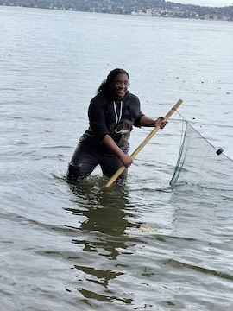 | 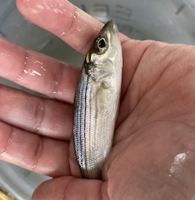 | 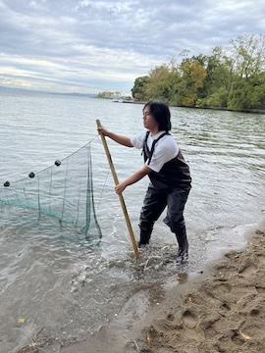
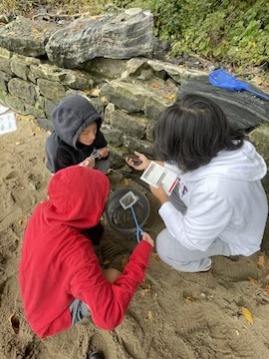 | 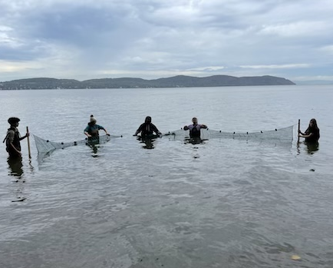 | 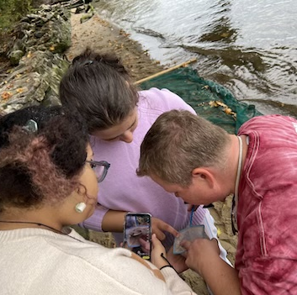
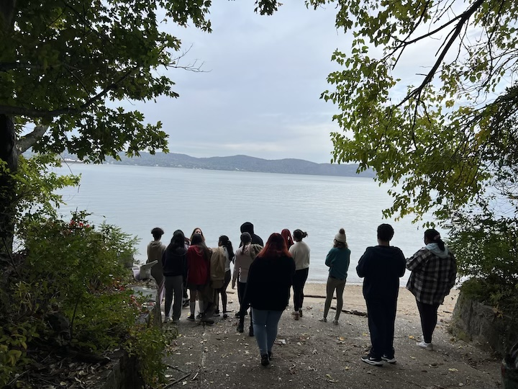
Location: Kathryn Davis River Walk Center, Kingsland Point Park, Sleep Hollow, Westchester NY
Area: Beach next to the Kathryn Davis River Walk Center
Sampling Site: Beach; riprap; drain pipe in the wall
Surrounding Land Uses: 100% Beach
Shoreline: Sandy, rocky
River Bottom: Muddy, sandy, rocky
Water: Choppy
Plants in the Water: No plants in the water
*NR = Not read/recorded

ITEM |  | Time |  | Reading |  |  |  | Comments
Physical
Air Temperature- |  | 1:45 PM |  | 19°C |  |  | 66°F
Wind Speed: |  | 1:45 PM |  | Anemometer  NR |  |  | Beaufort  <1 | Direction  NR
Weather today |  | 1:45 PM |  | >75% cloud cover |  |  | Drizzle
Weather the past 3 days: |  | Foggy
Tides- *see note |  | Time |  | Rising, Falling, Unchanged |  |  | Water Height (cm) | *Tide came in fast and ran samplers off the beach!
 |  | 9:30 AM |  | Rising |  |  | 32 cm
Current- NR |  | Time |  | Cm/sec |  | Knots | North/South | Ebb/Flood/Still
Water Temperature- |  | 9:19 AM  9:45 AM  10:15 AM  1:45 PM |  | 19°C  19°C  17°C  14°C |  |  | 66°F  62.6°F  62.5°F  57.2°F
Turbidity- Long Sight Tube (120 cm) |  | 10:18 AM  1:45 PM |  | 74.4 cm  85 cm
Chemical
Salinity-LR Quantabs* assume this exceeded the capacity of the LR |  | 10:27 AM |  | 2 ppt* not realistic based on the salinity this year
Standardized Salinity – HR Quantabs |  | 11:21 AM |  | 8536 ppm
DO – Hach Drop Count Kit |  | Time  10:34 AM 1:45 PM |  | Temp  16°C  14°C |  |  | ppm DO  12 ppm  10 ppm | % saturation  NR  100%
pH –Color Match Kit |  | 10:47 AM  1:45 PM |  | 7.6  8
Biological-
Fish – Seine – 10 pull |  | Number |  | Name |  |  | Length of longest | Length of smallest
9:45 AM-10:45 AM |  | 20  1 |  | Atlantic Silverside  Striped Bass |  |  | 6.5 cm  8 cm | 6 cm
Fish Totals |  | TOTAL: |  | Diversity:
Macroinvertebrates |  | Number |  | Name |  |  | Length of longest | Length of smallest
 |  | 1  25 |  | Blue Crab  Moon Jellies |  |  | 1.5 cm
Macroinvertebrate Totals |  | TOTAL: 26 |  | Diversity: 2
Sediment Core – NR
Length | H2S smell |  | Oxid Top |  | Oil |  | Grain Size | Other Features
Boats-
 | Time |  | Name |  | Color |  | North/Southbound | Light/Loaded
Commercial | 9:20 AM |  | Barge |  | White/Green |  | Southbound | Light
Recreational

